Network Security Lab-1

**Lab: Connecting Networks with Google Cloud VPN using Route-based.**

**Before doing this Lab, you have to create the following environment on the GCP.**

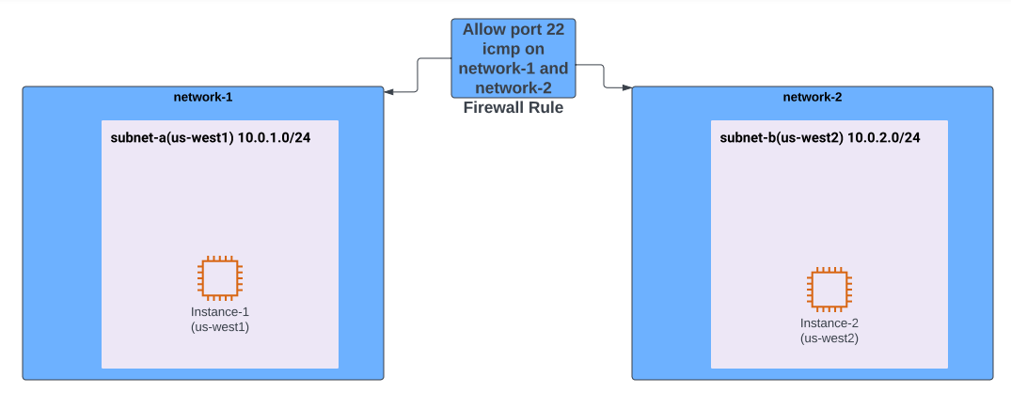

**\*\***

**There is a document to create VPC network-1 with subnet-a and VPC network-2 with subnet-b VPC Networks.**

**There is another document to create instance-1 connected to network-1(subnet-a) and instance-2 connected to network-2(subnet-b)**

**There is a one more document to create firewall rule for network-1 and network-2 which allow port 22 icmp ( Helps you to access SSH)**

**\*\***

***Note: It is important to create the specific environment, if not it leads to confusion.***

**Introduction:** You do not specify local or remote traffic selectors; instead, you use a Cloud Router. Route data is exchanged in real-time.

**Problem:** *A company must connect networks with Google Cloud VPN using Cloud Route (Route based)*

**Solution:** In this lab, we will connect two VPC networks using the Cloud VPN service, configured with dynamic routes using the Cloud Router service.

**Step1:** Create a Static IP Address for each VPN Gateway.

1. Once you first log in, your screen should look similar to this.

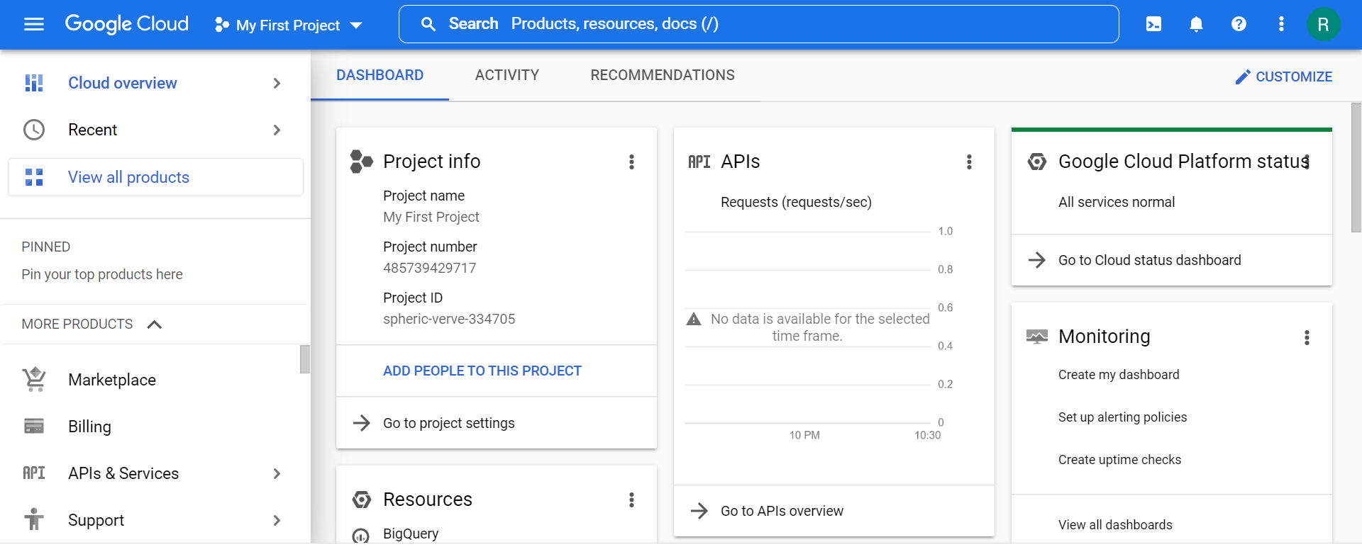

1. Click on the project selector drop-down menu at the top of the screen.

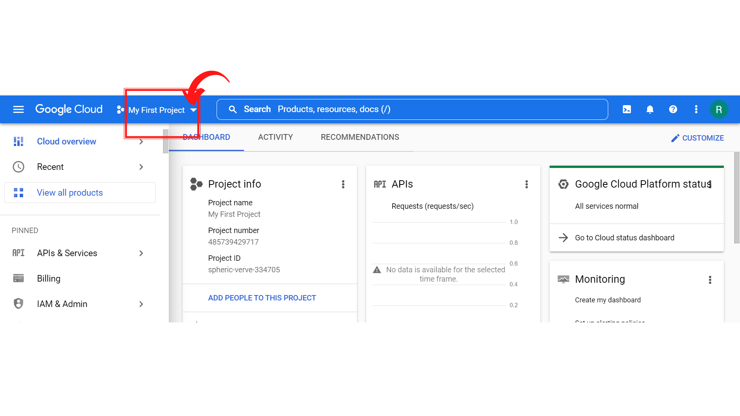

1. Since, we are doing labs on a Security Labs project, Click on *“Security Labs”*.

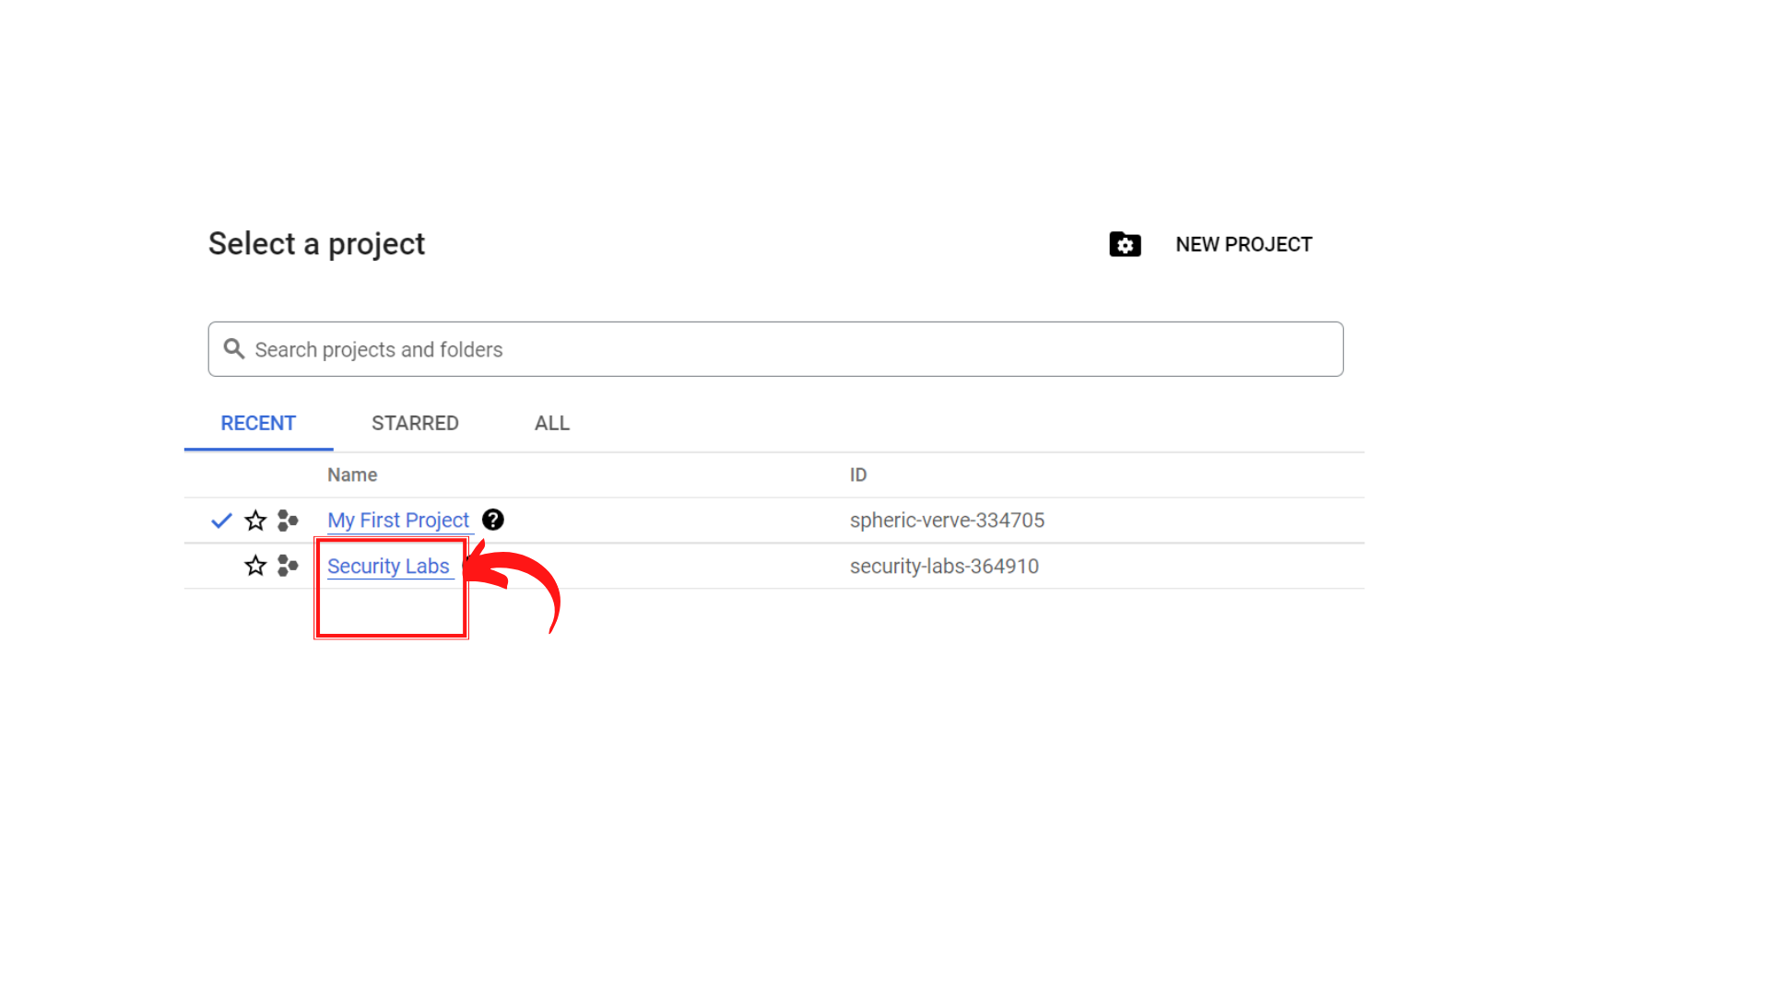

1. Your screen should look similar to this with project info changed to “*Security Labs”* project.

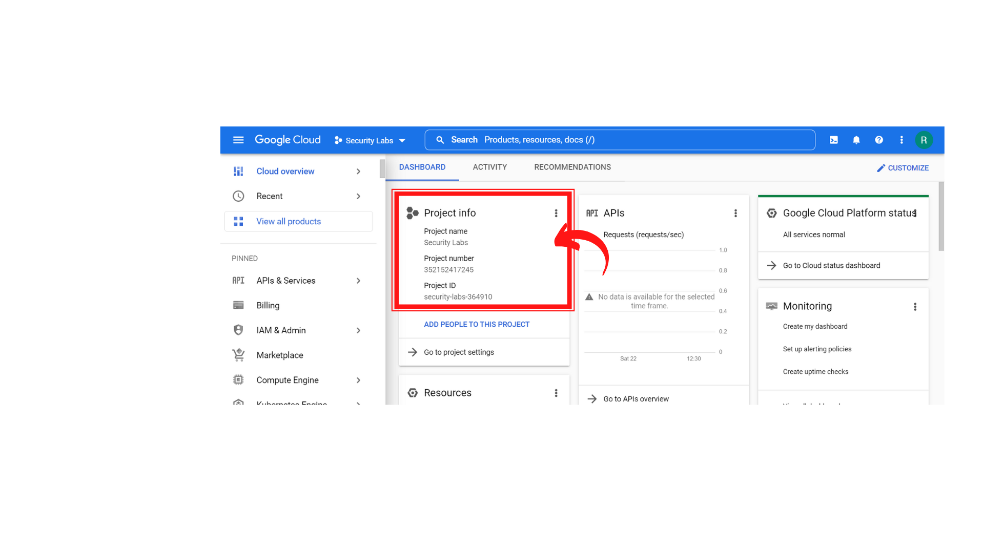

1. To create a new VPC Network, Click on *“Navigation menu”* on top left, then click on ***“VPC Network → VPC Networks”***

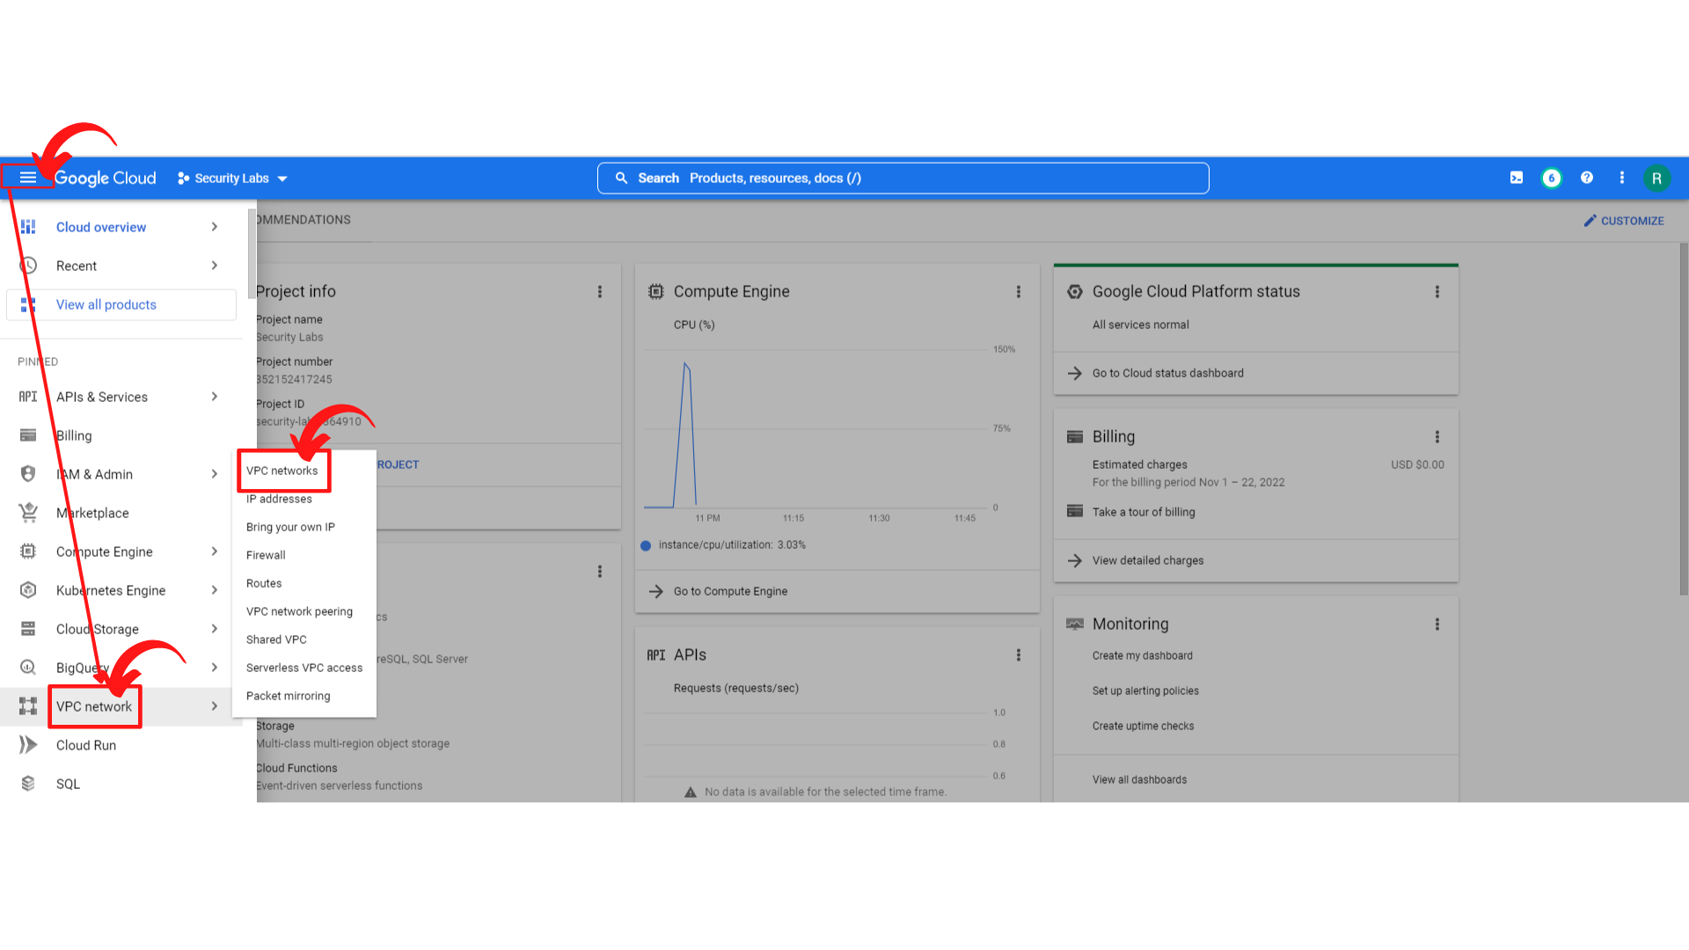

1. Your screen should look similar to this.

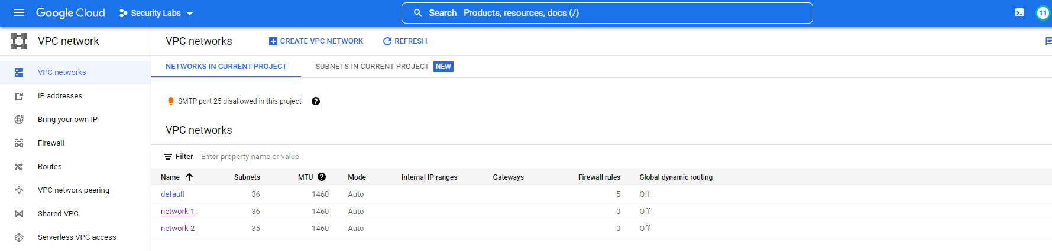

1. Now **“C*lick → IP addresses”*** then “***click → Reserve External static address”***

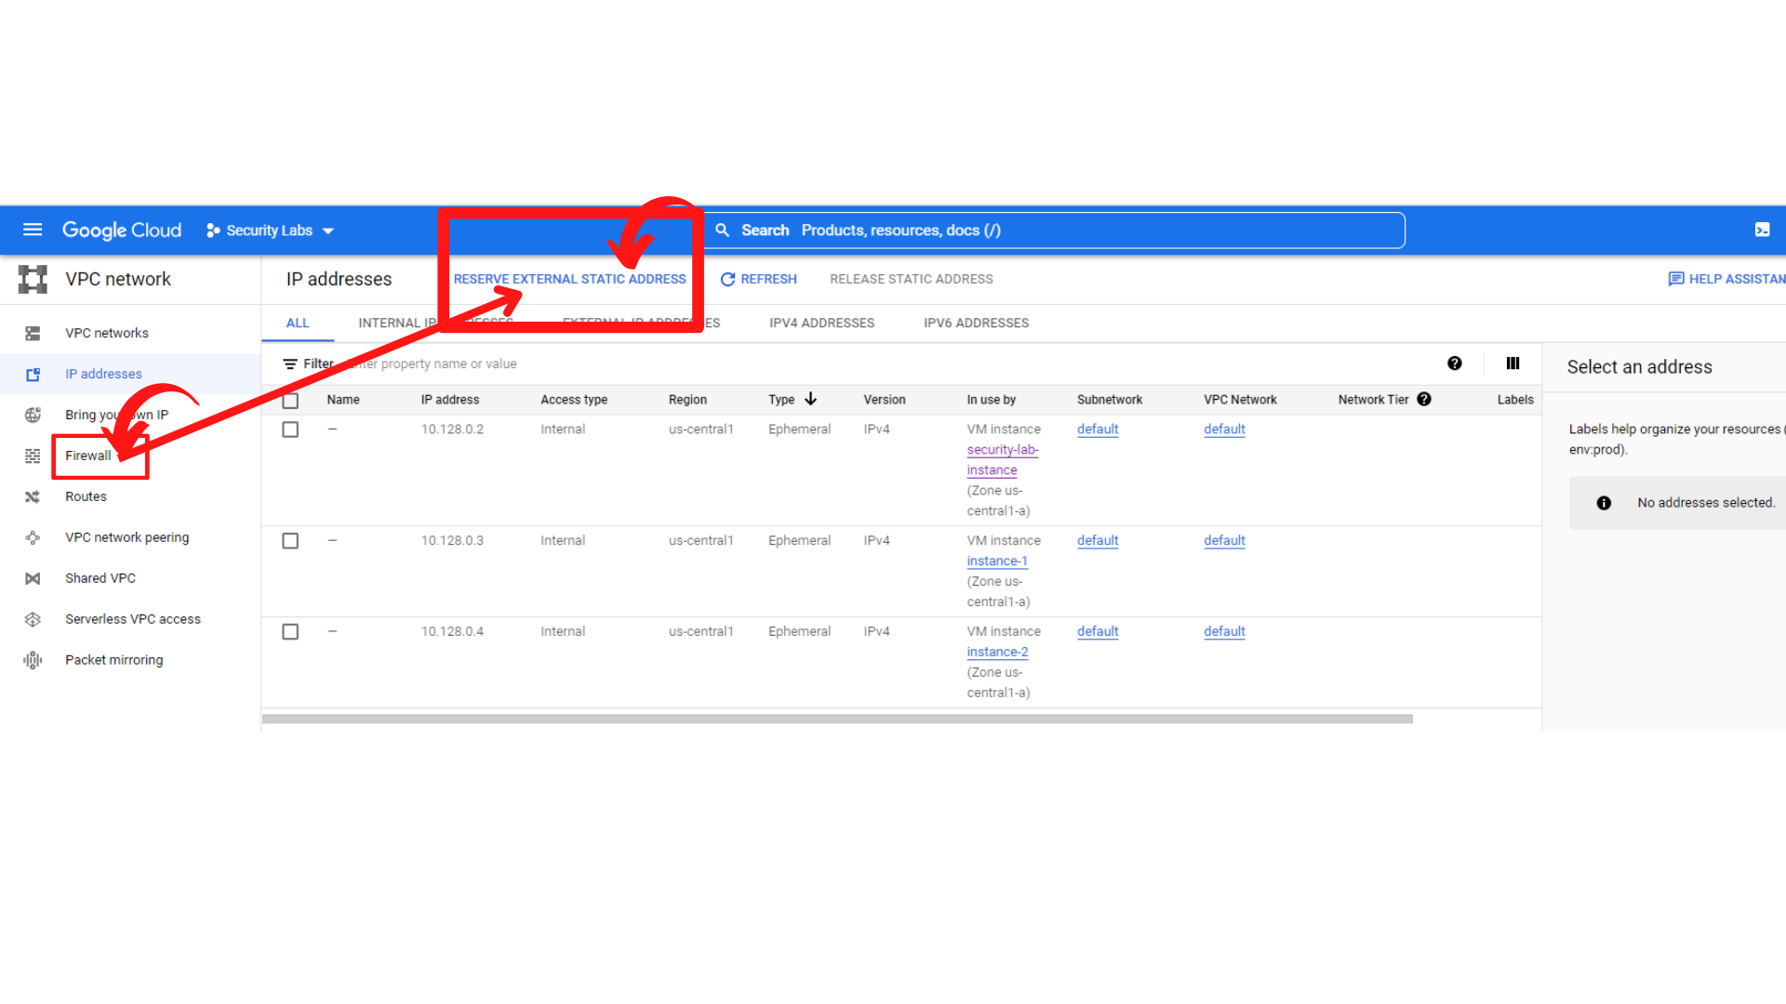

1. You will a Reserve a static address form. Enter the

**Name : ips-gateway-address-1**

**Region: us-west1 (Oregon)**

**Leave all other settings as “default”**

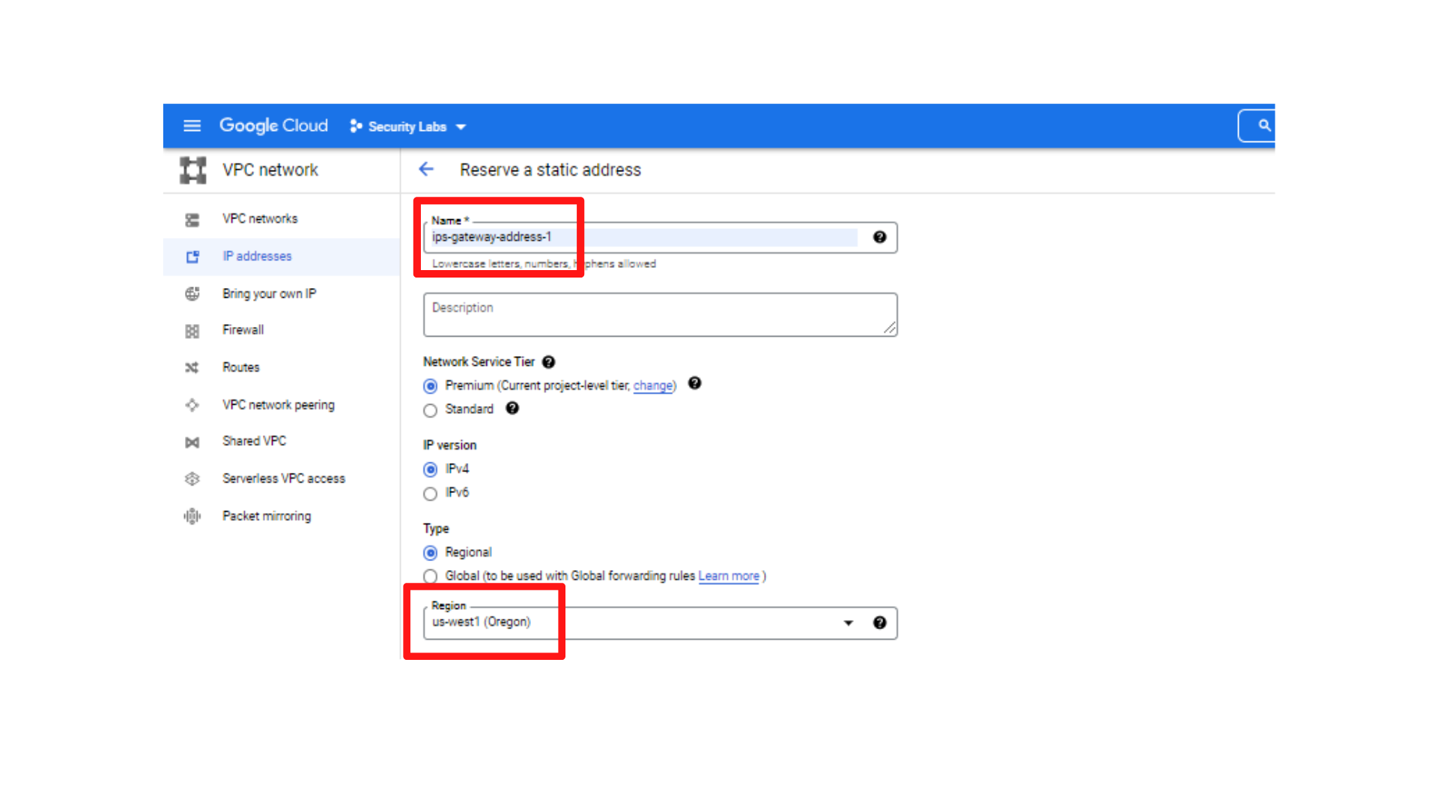

1. After the filling above details, *“Click → Reserve”*

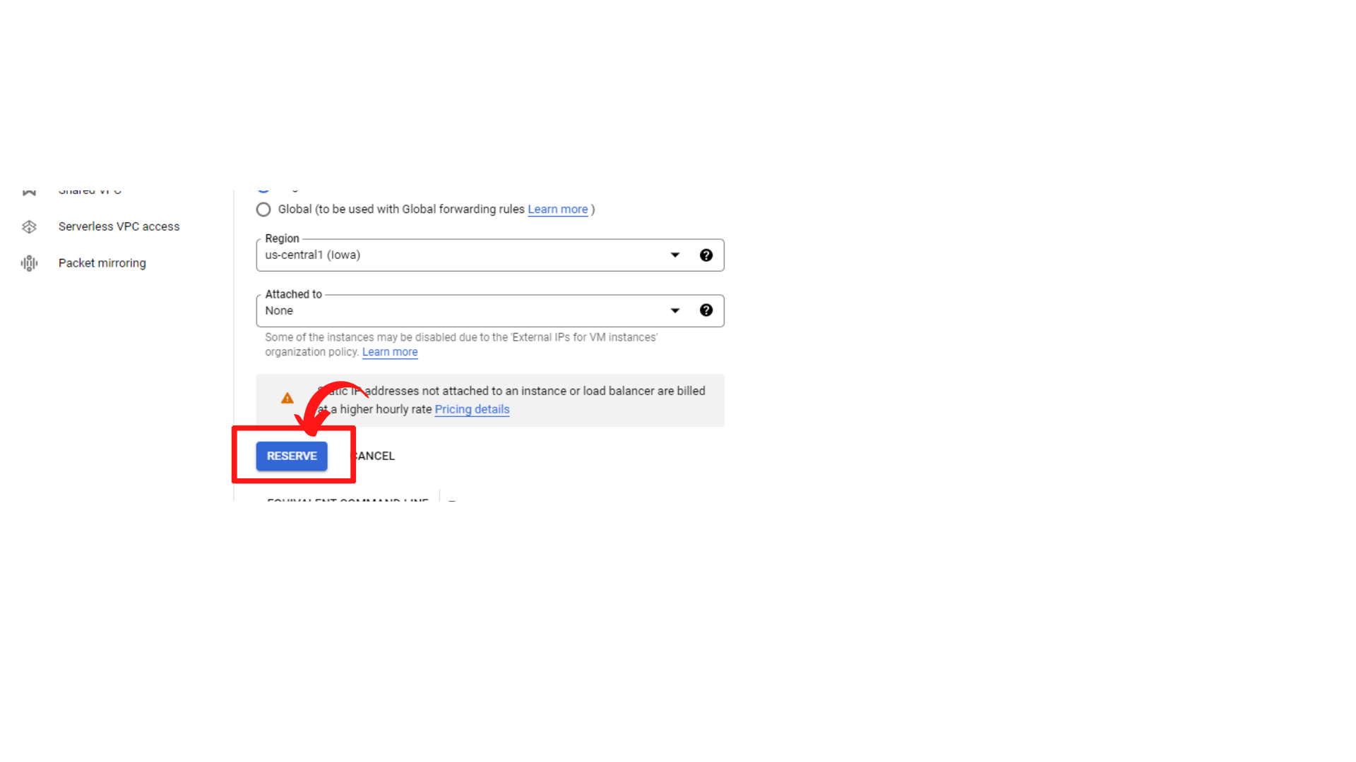

1. Your screen should look similar to this with a new reserved IP address.

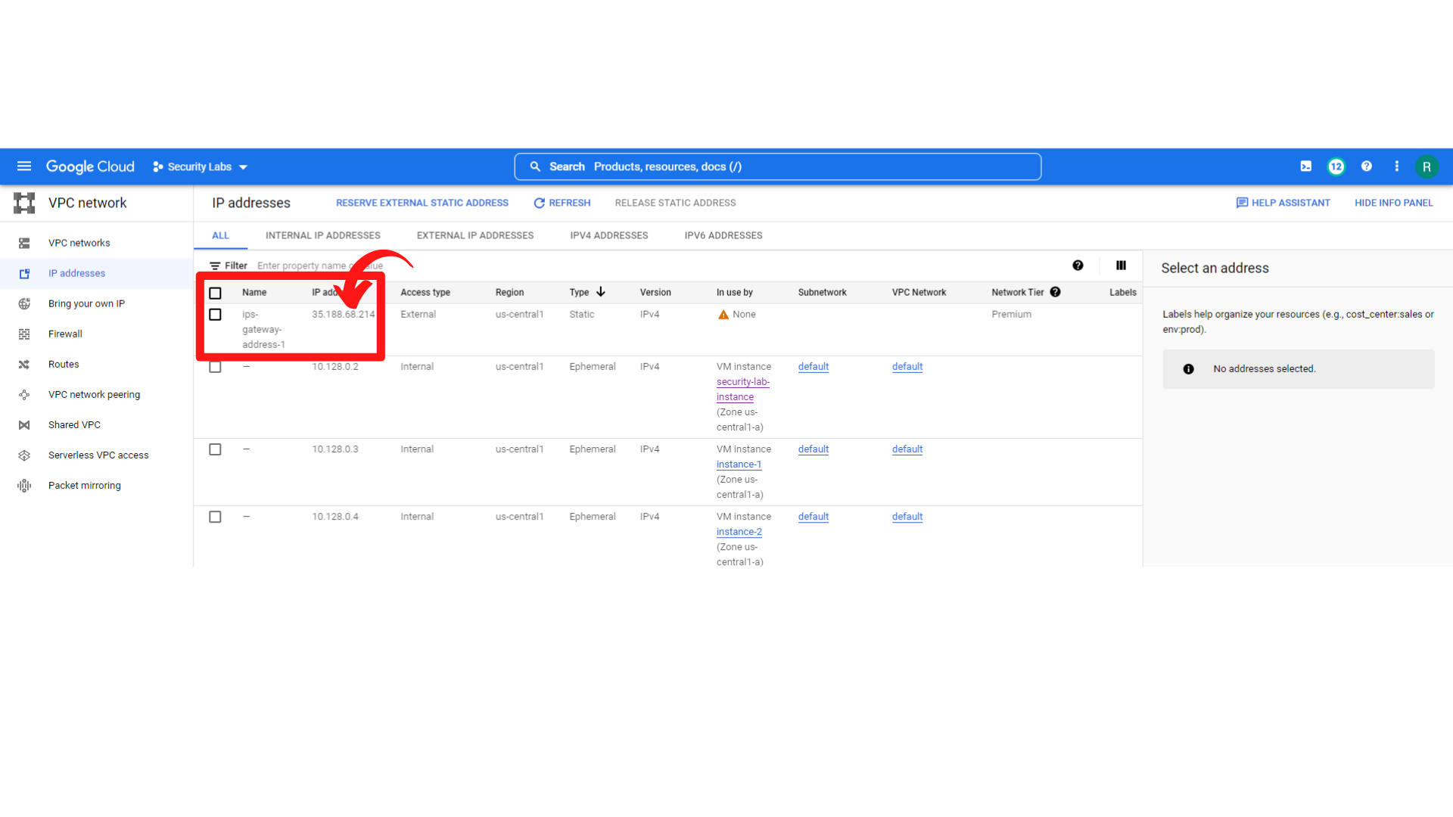

1. Now create one more static IP address with ***“Name: ips-gateway-address-2”*** and set   
   “***Region → us-west2 (Los Angeles)***”

***“Leave all other setting as default”*** then ***“Click → Reserve”***

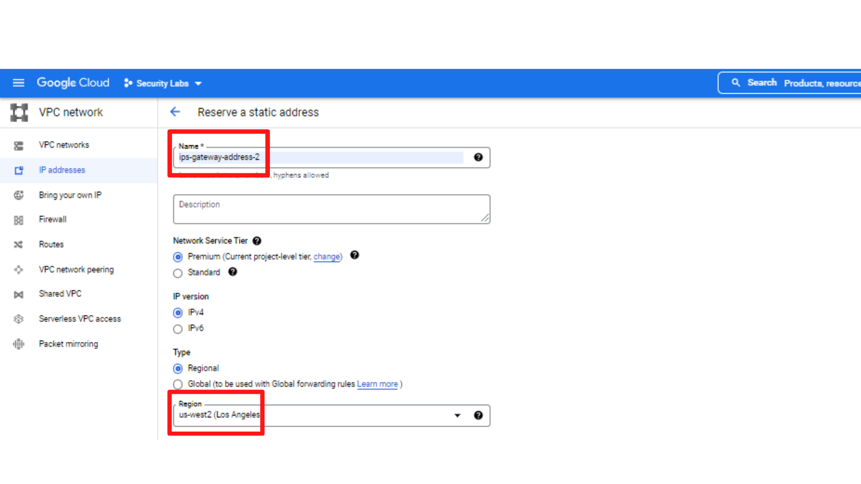

1. Now your screen should look similar to this with two static IP addresses Reserved.

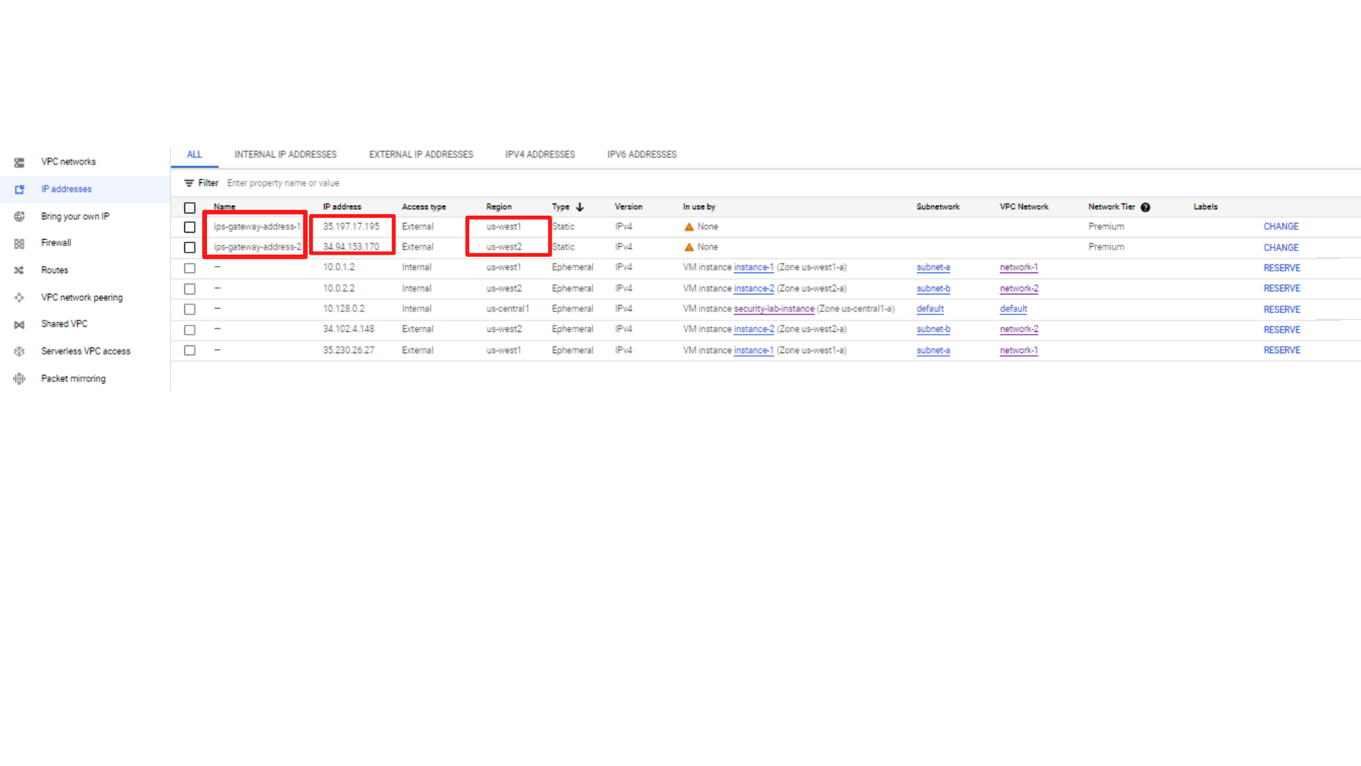

Here my static Reserve IPs

ips-gateway-address-1: 35.197.17.195

ips-gateway-address-2: 34.94.153.170

**Step2:** Now you need to Enable Dynamic Global Routing on each VPC Network. i.e on network-1 and network-2.

1. Your screen should look similar to this after creating static IP addresses.

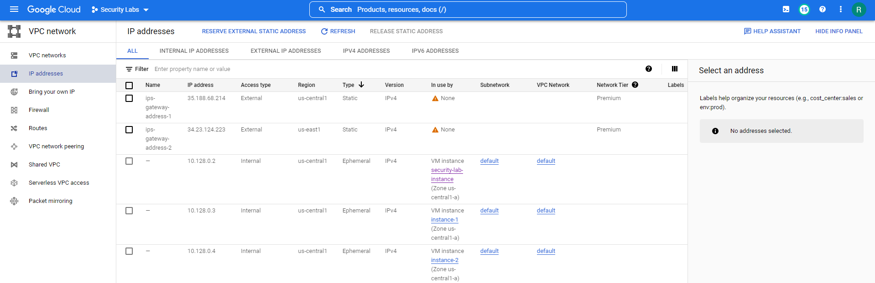

1. Now ***“Click → VPC networks”***

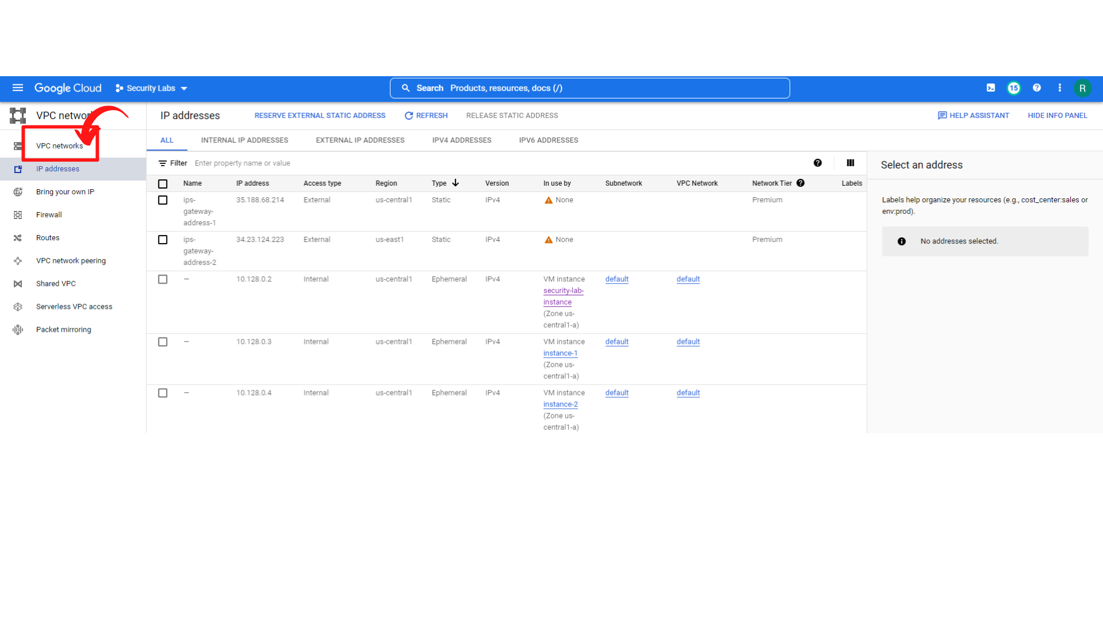

1. Your screen should look similar to this and ***“click → network-1.”***

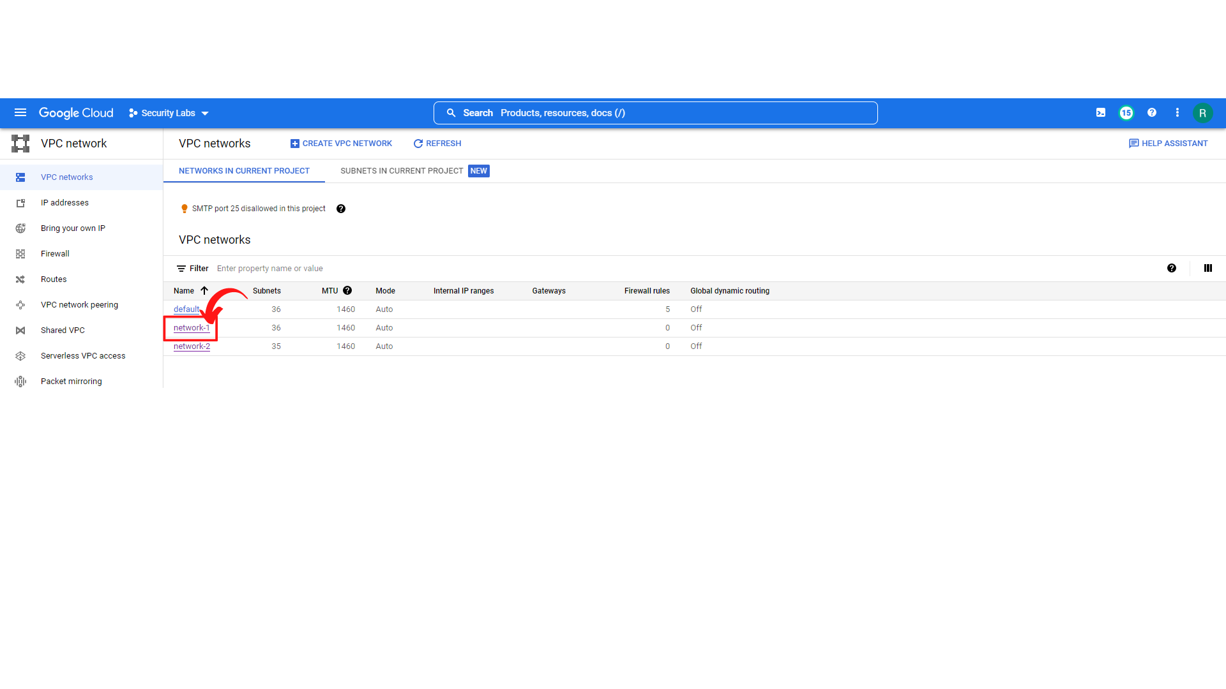

1. Your screen should look similar to this with network-1 details, ***“Click → EDIT”***(Top Middle).

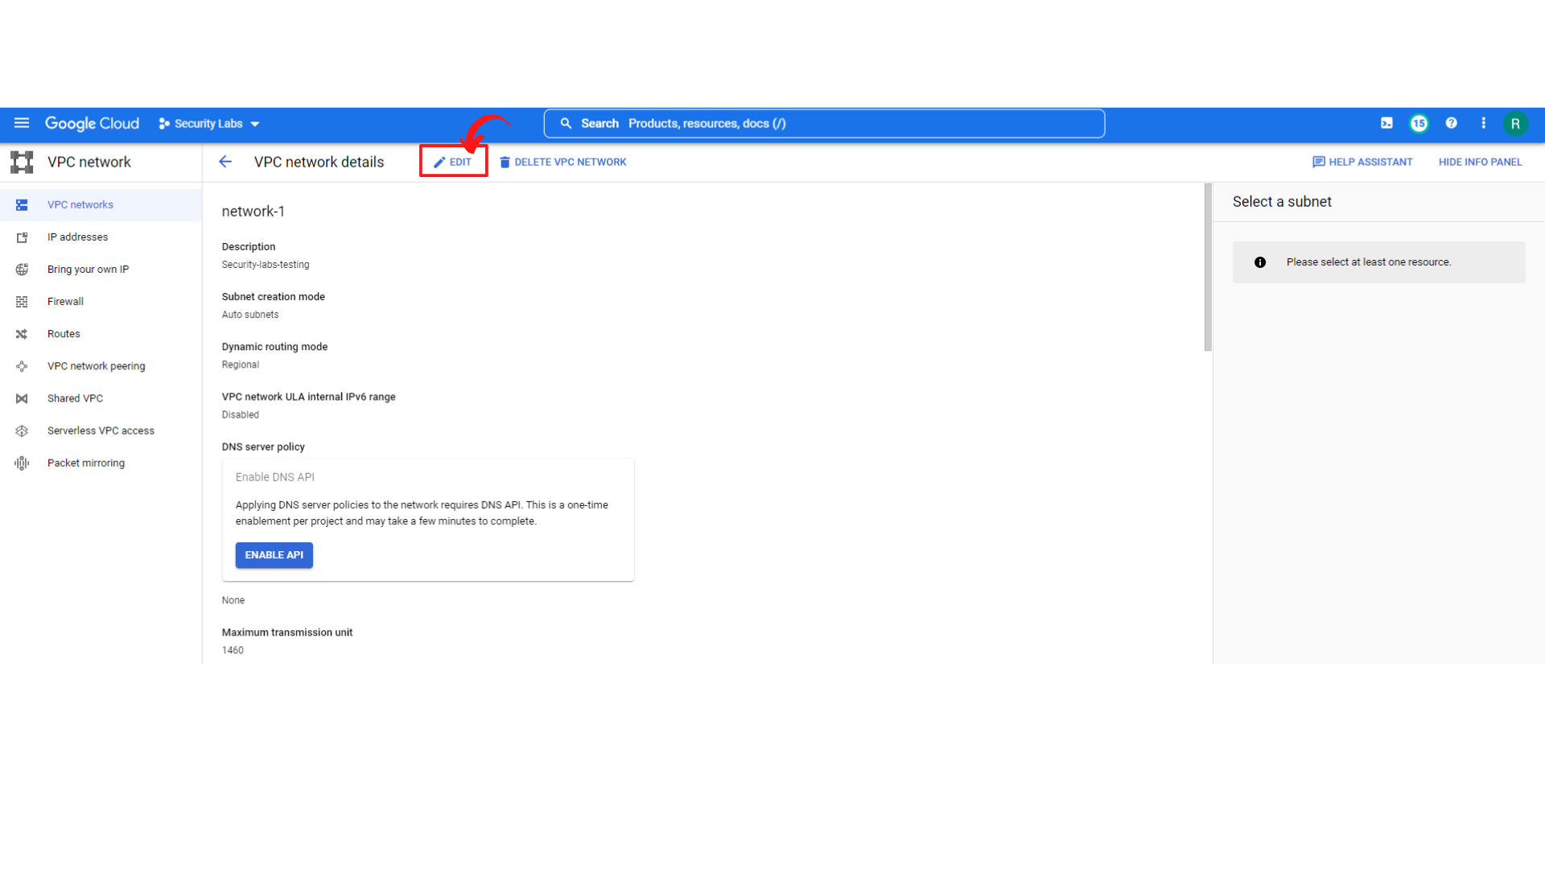

1. Now change ***“Dynamic routing mode from Regional to Global”***  and ***“Click → Save”***

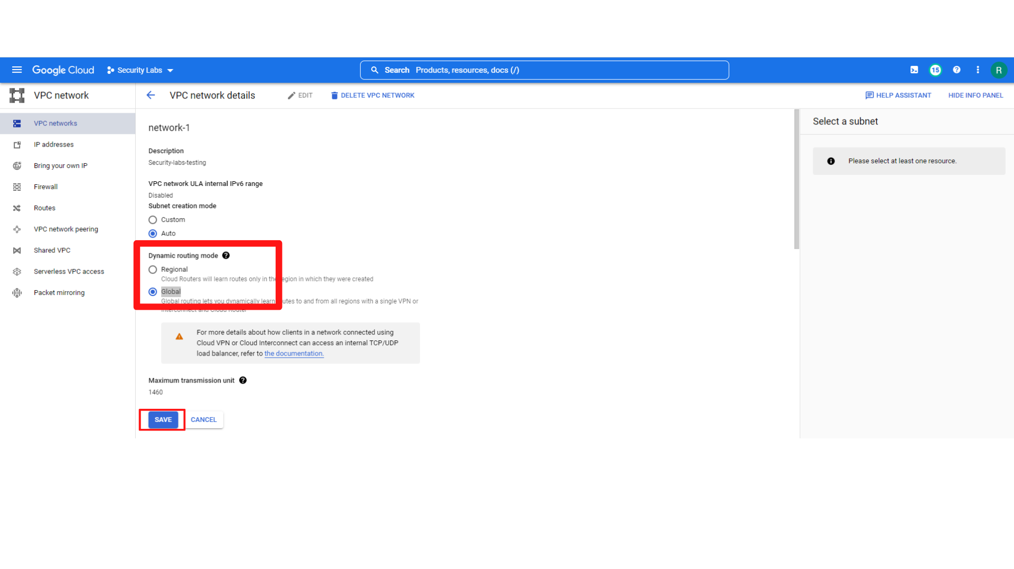

1. Now you will see similar screen to this with **“network-1 Global dynamic Routing → On”**

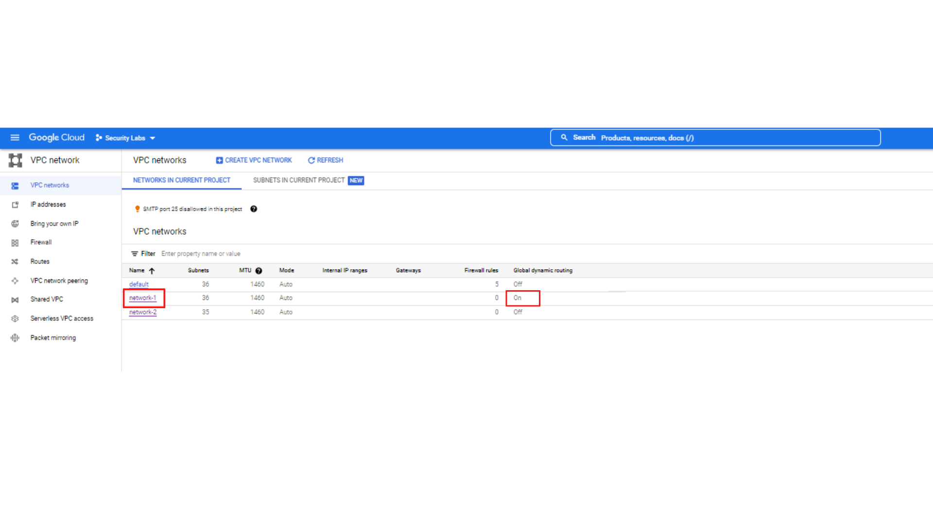

1. Now Enable Dynamic Global Routing on network-2.
2. Repeat the same process as you did for network-1.

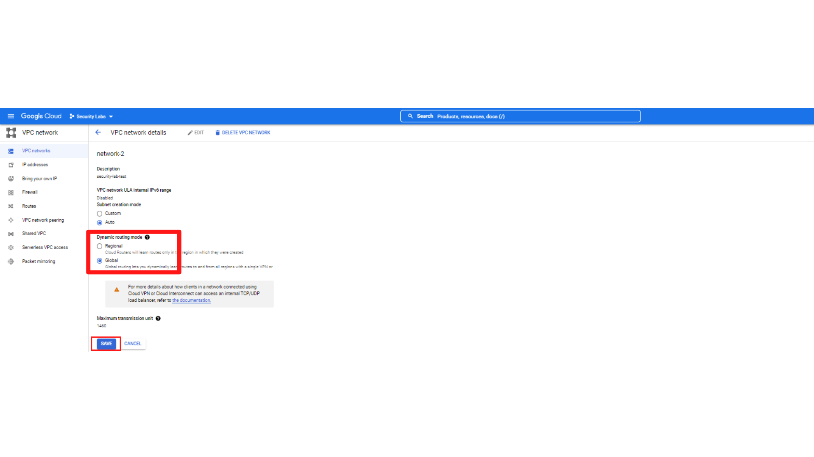

1. Now you will see a similar screen to this with ***“network-1 and network-2 Global dynamic Routing → On”***

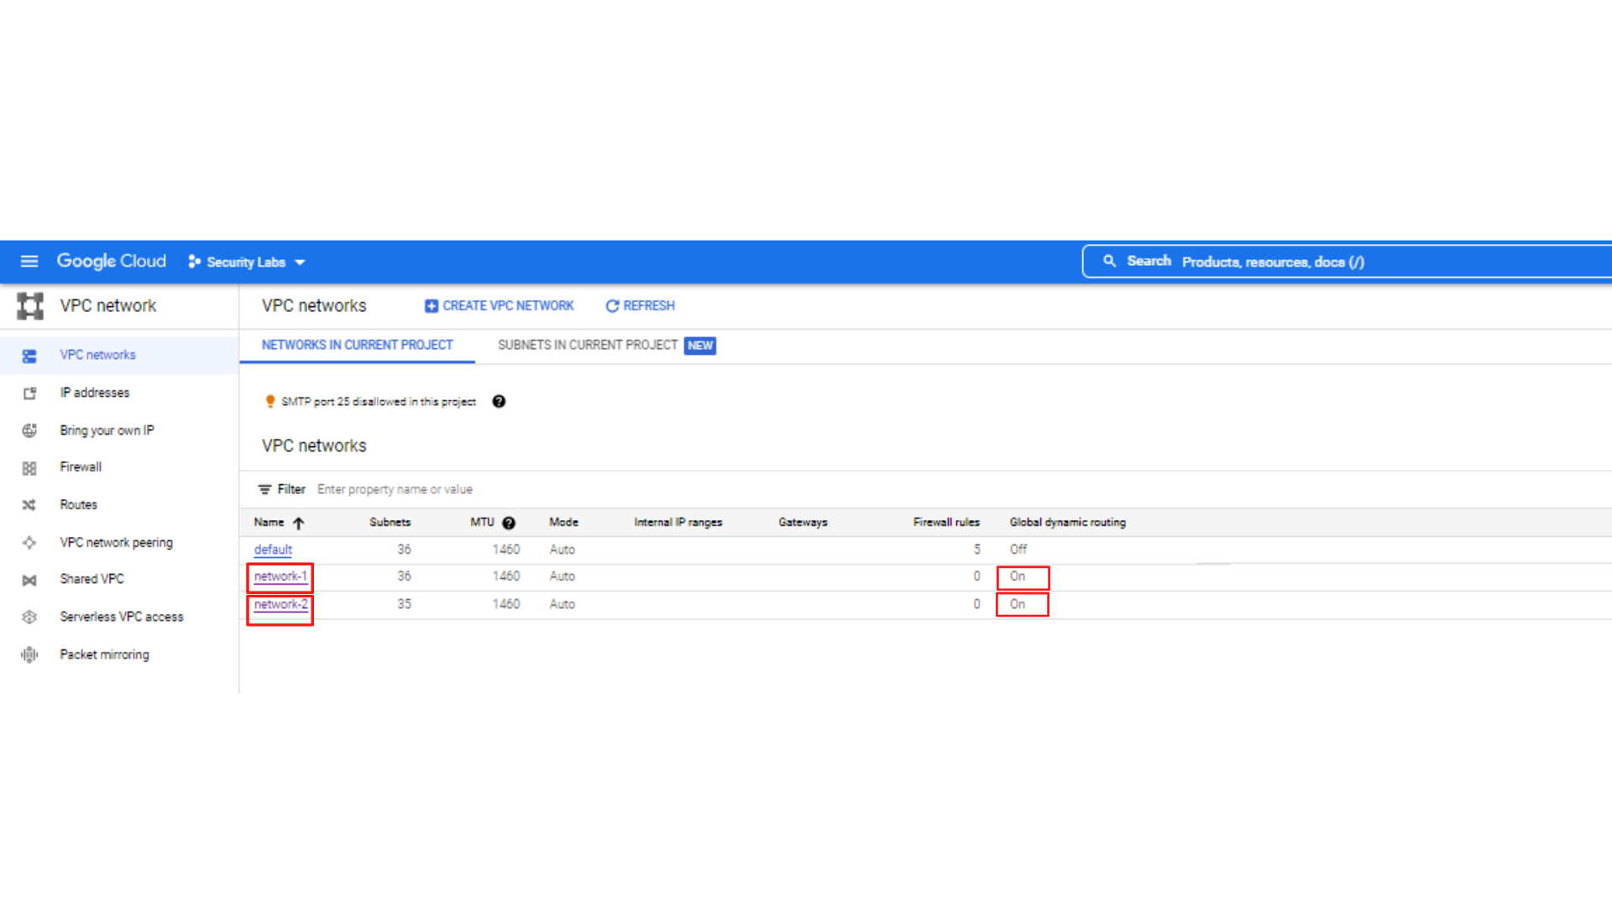

**Step3:** Now create Your First VPN Gateway and Tunnel for network-1.

1. Now you will see a similar screen to this with after Enabling Global Dynamic Routing on network-1 and network-2. Now Click on ***“Navigation menu”*** on top left and scroll down to see and click ***“Hybrid Connectivity → VPN”*** and ***“Click → Create VPN Connection”***

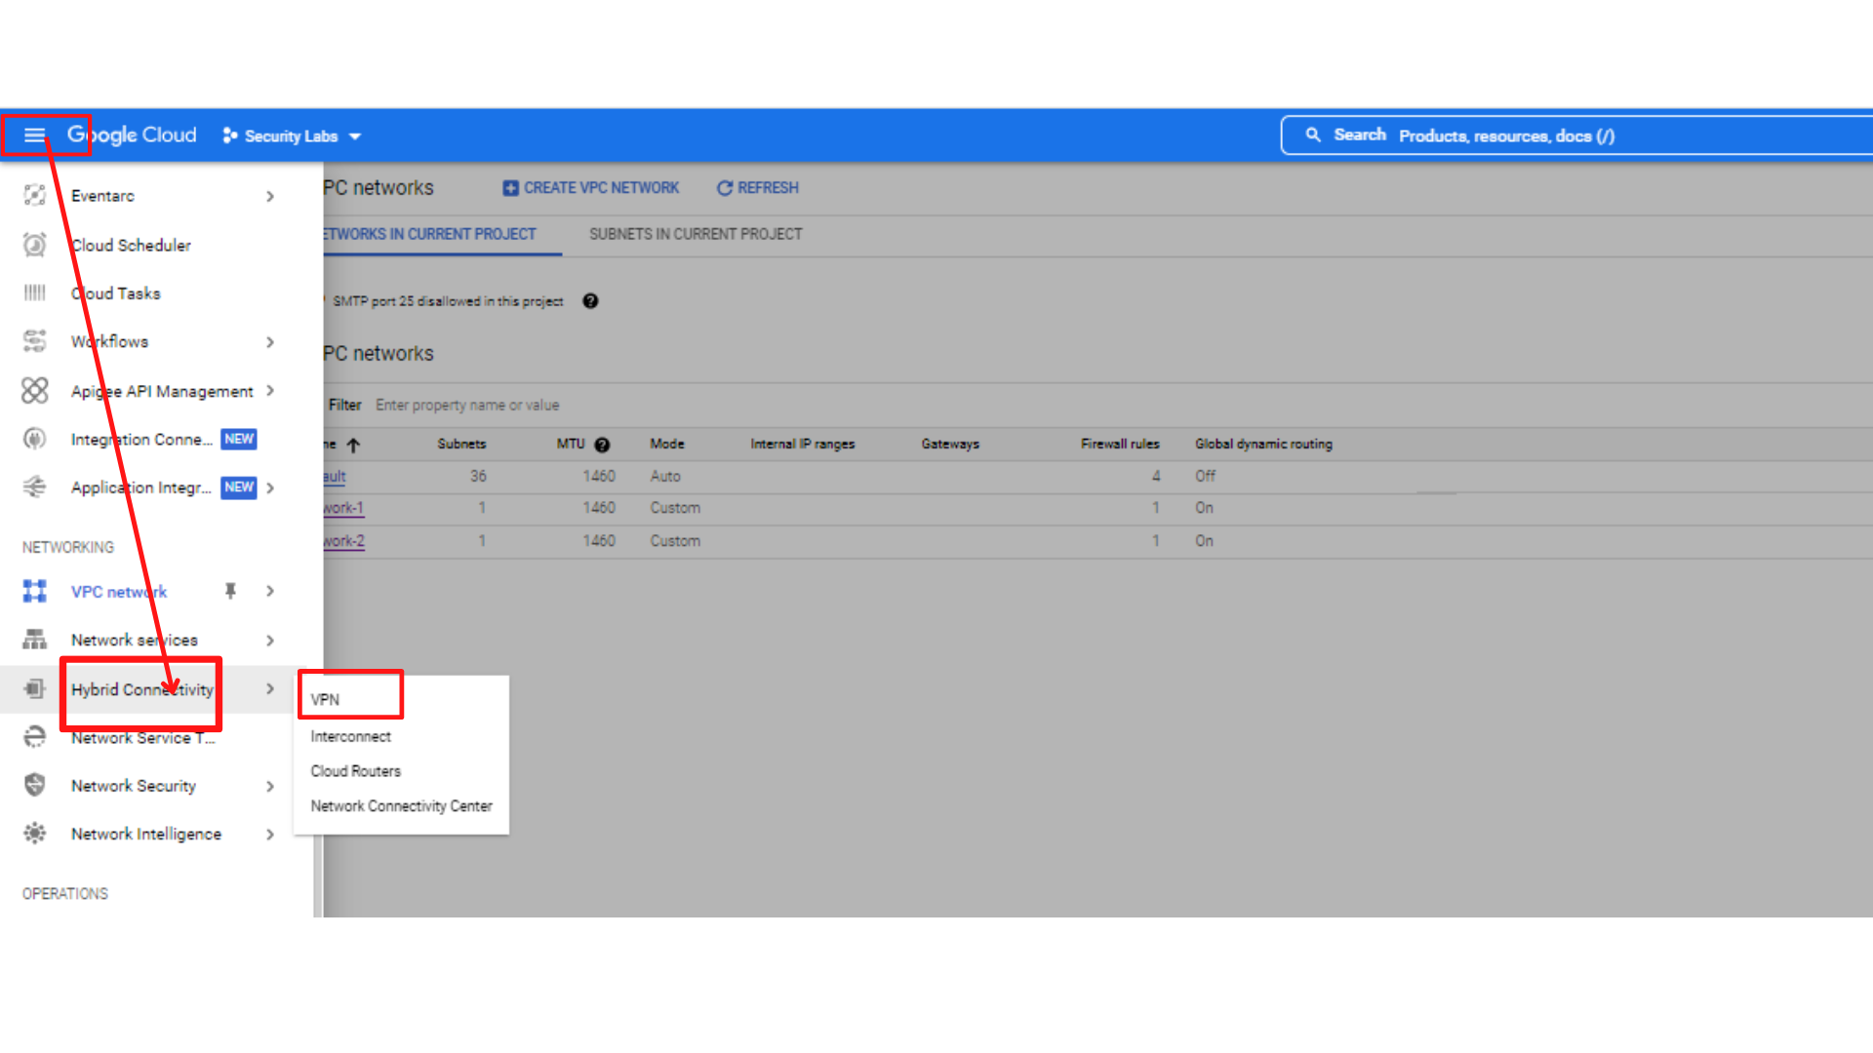

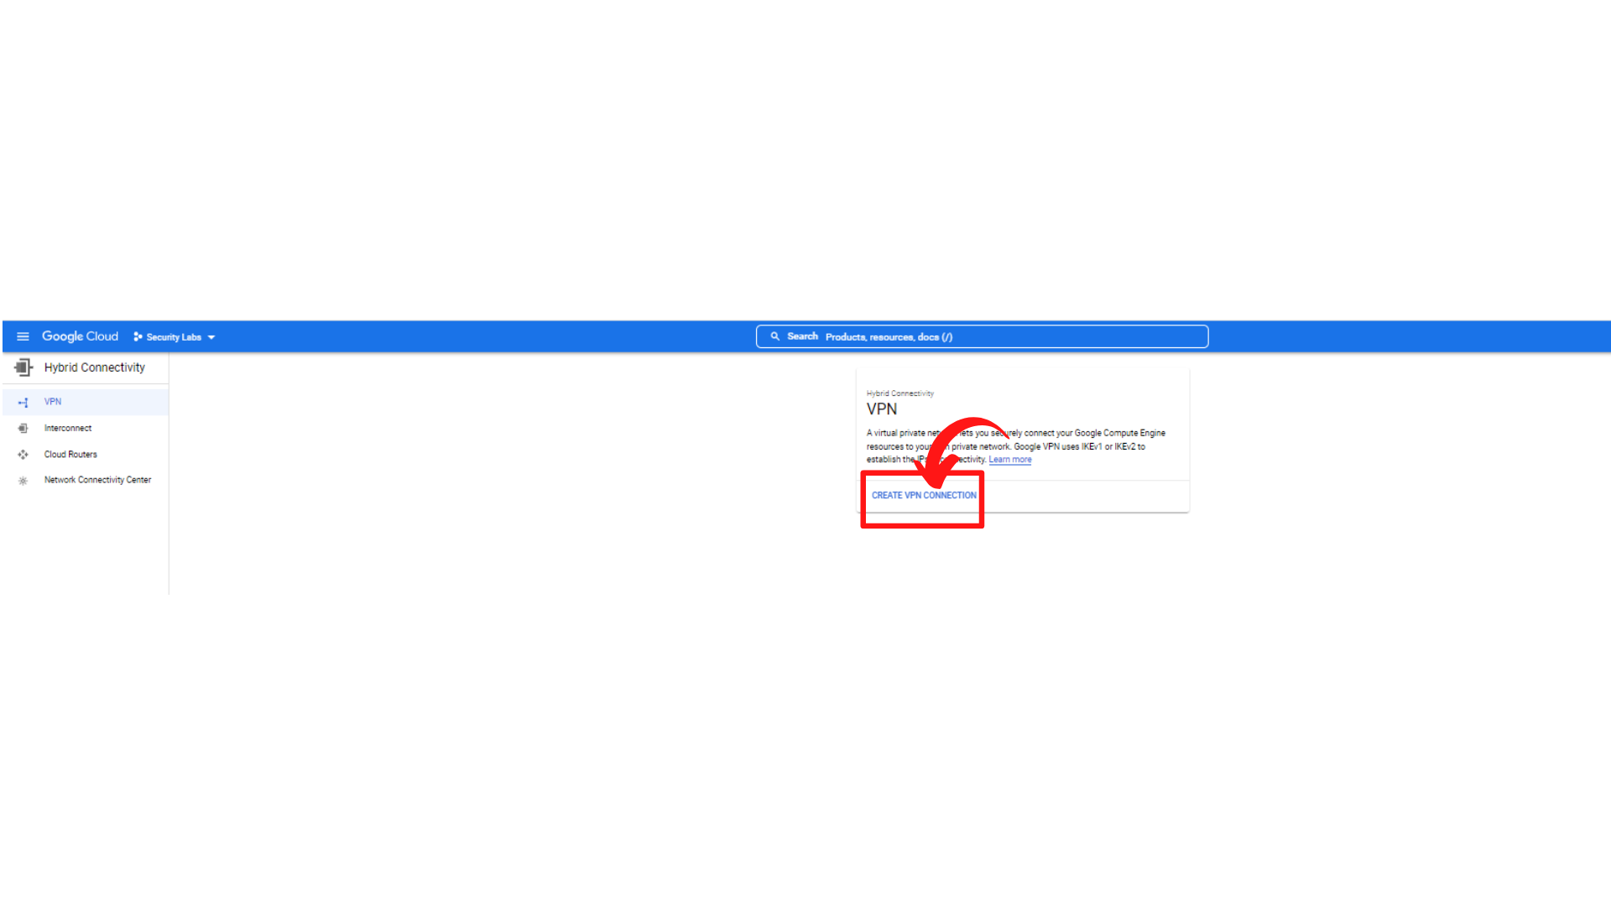

1. Now you will see a similar screen to this and select ***“Classic VPN” and “click → Continue”***
   1. ***Note: Please Use Classic VPN option***

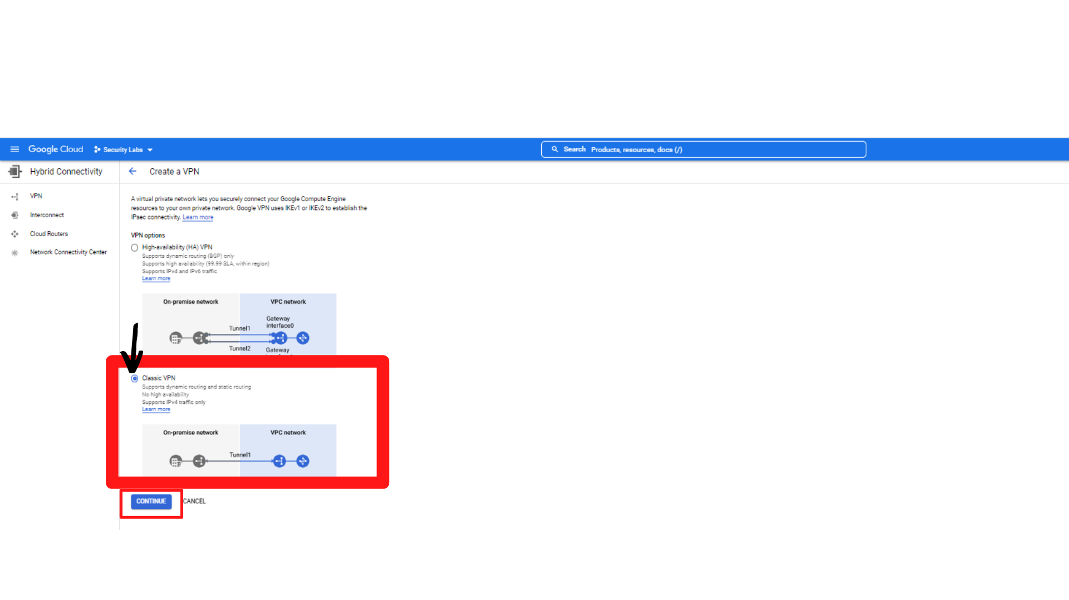

1. Now you will see a similar screen to this with ***“Google Compute Engine VPN gateway”*** Form, Enter the following information.

**Name: *“vpn-gateway-1”***

**Network:** Select “***network-1”***

**Region:** select ***“us-west1 (Oregon)”***

**IP address:** Select ***“ips-gateway-address-1”***

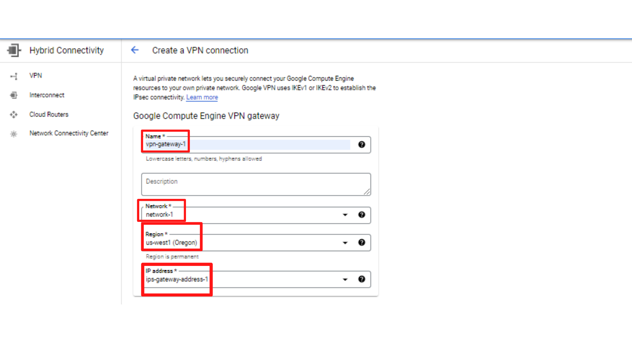

1. Now scroll down, you will see “Tunnels” Form.

Enter the following information.

**Name:** ***vpn-1-tunnel-1***

**Remote peer IP address:** ***“ips-gateway-address-2”*** you need add second static reserved IP address i.e ips-gateway-address-2

**IKE pre-shared Key:** click on ***“Generate and copy”***

**\*\* Copy the shared key on text file, we will use same key for second VPN\*\***

**Routing options:** Select ***“Route-based”***

Remote IP Network Ranges: Enter the instance-2 network-2 -subnet-b IP range i.e **10.0.2.0/24**

Then **“click → Done”**

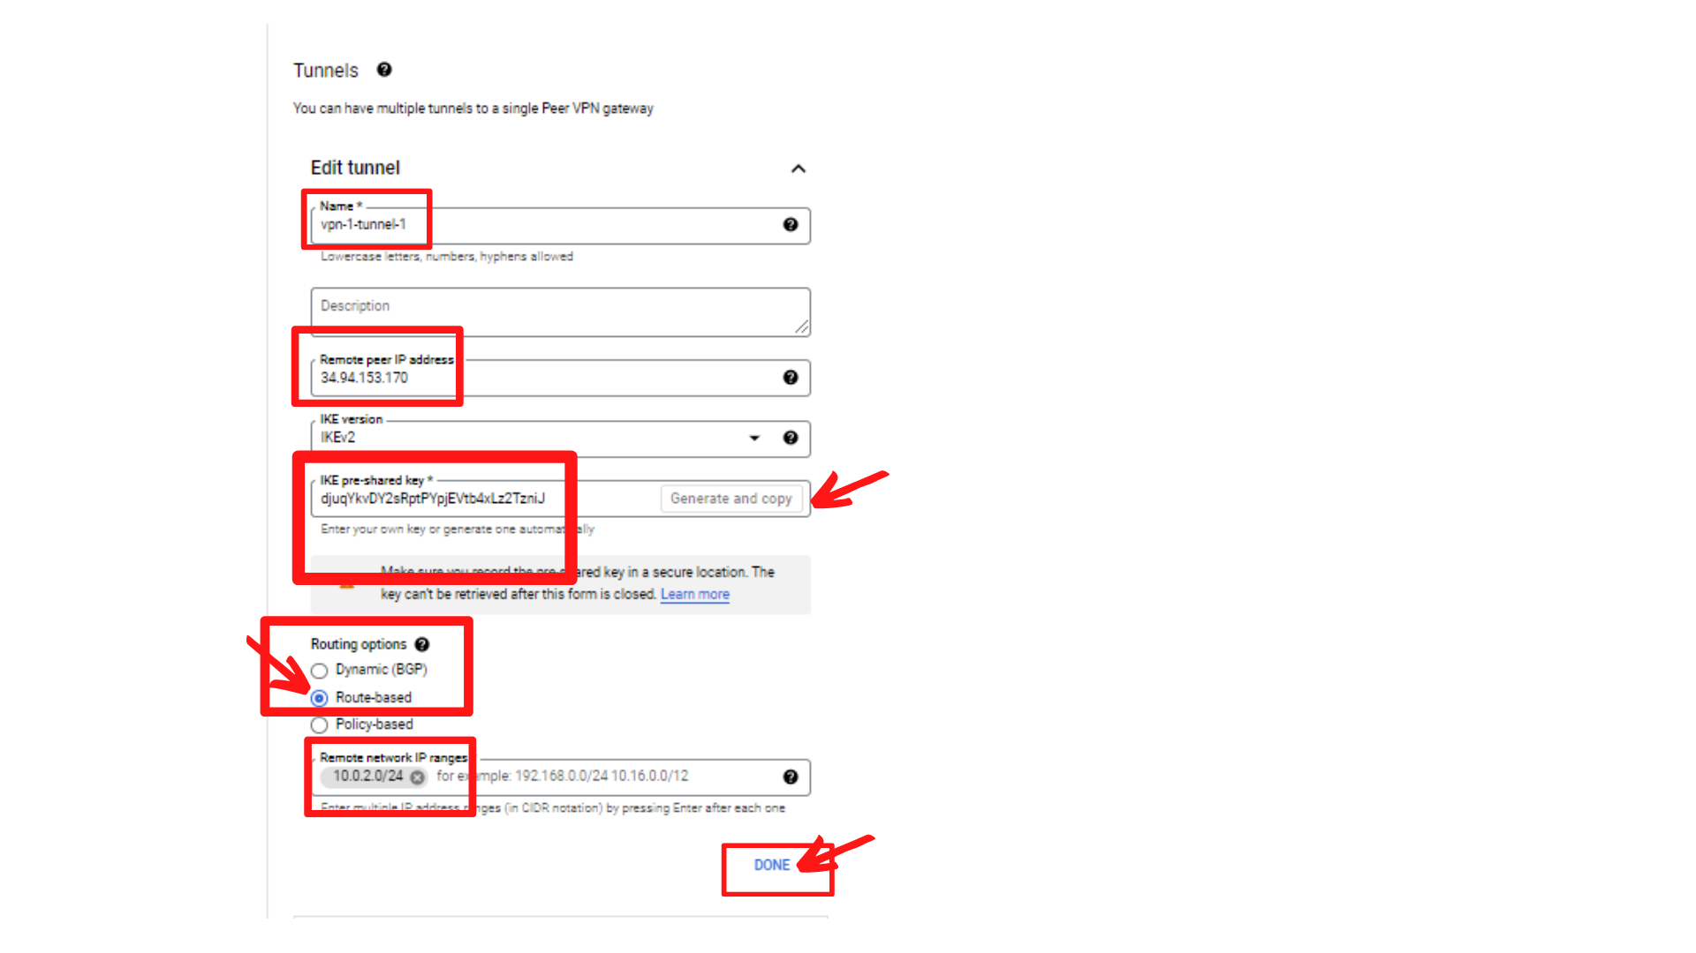

1. Then ***“click → Create”***
2. Your screen should look similar to this with a new VPN and tunnel for network-1.

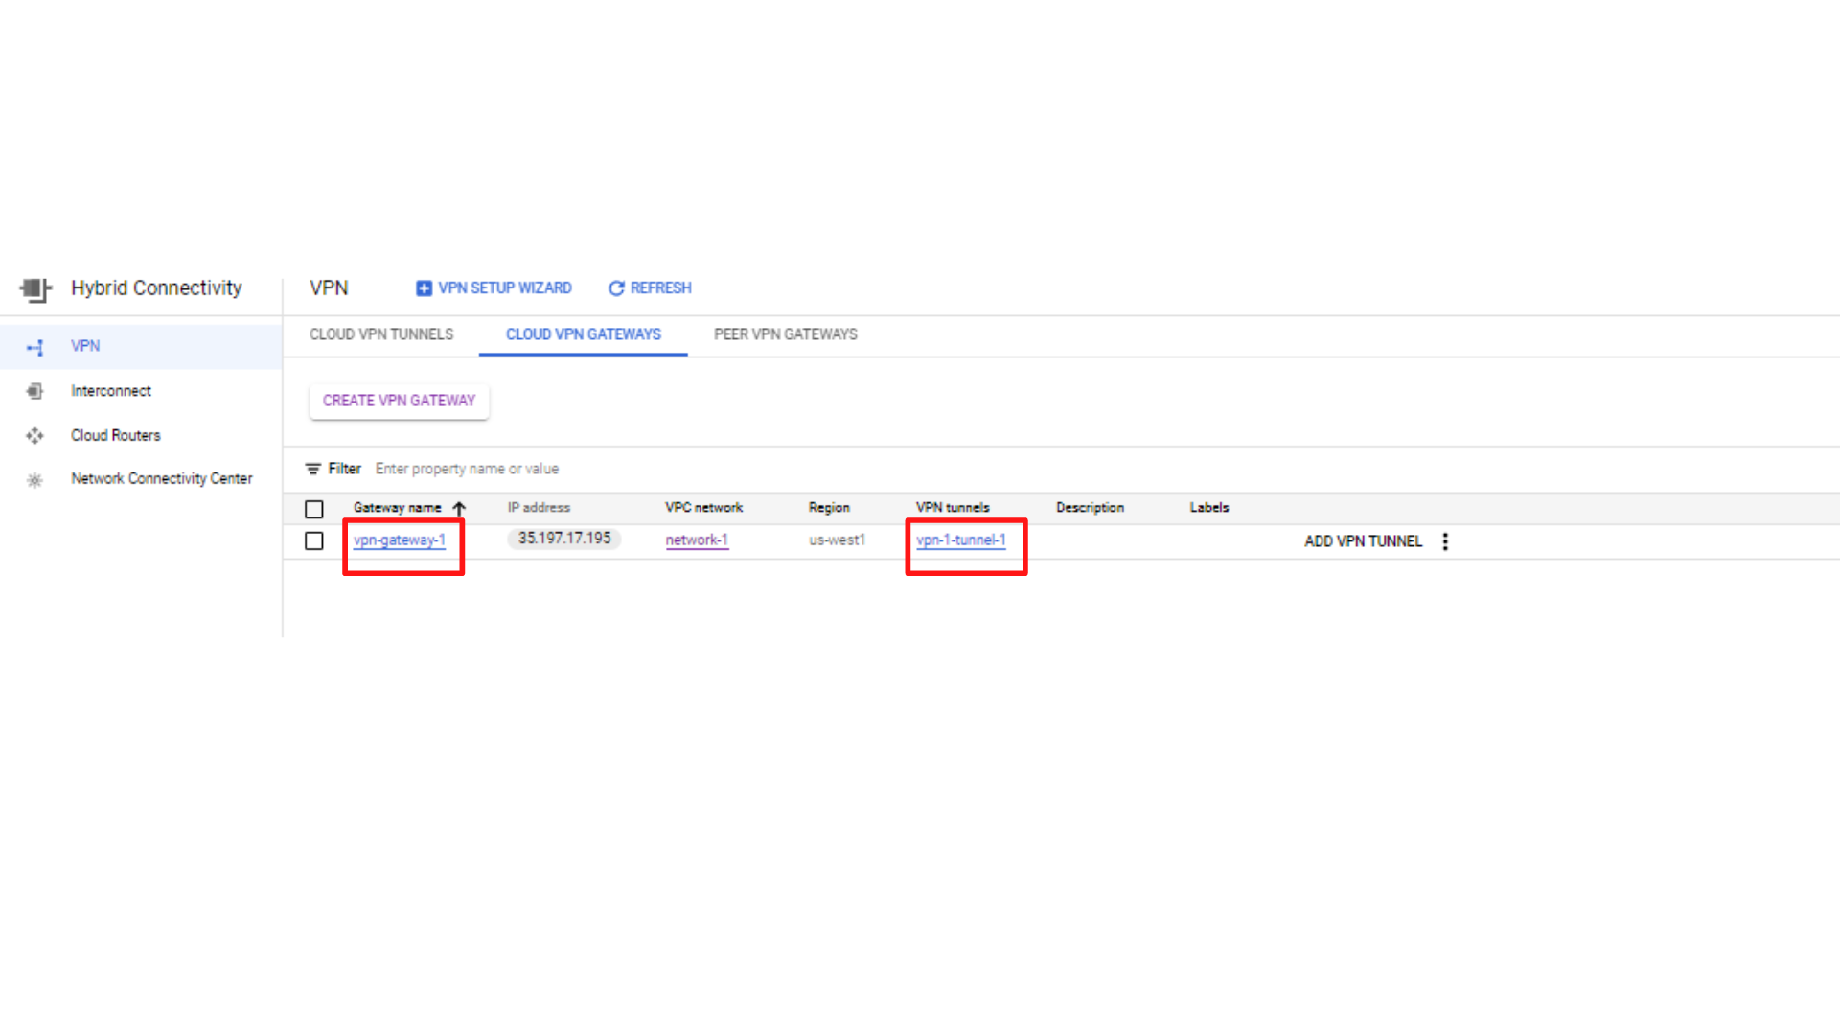

**Step4:** Now create Your Second VPN Gateway and Tunnel for network-2.

1. Your screen should look similar to this and ***“click → Create VPN Gateway”***

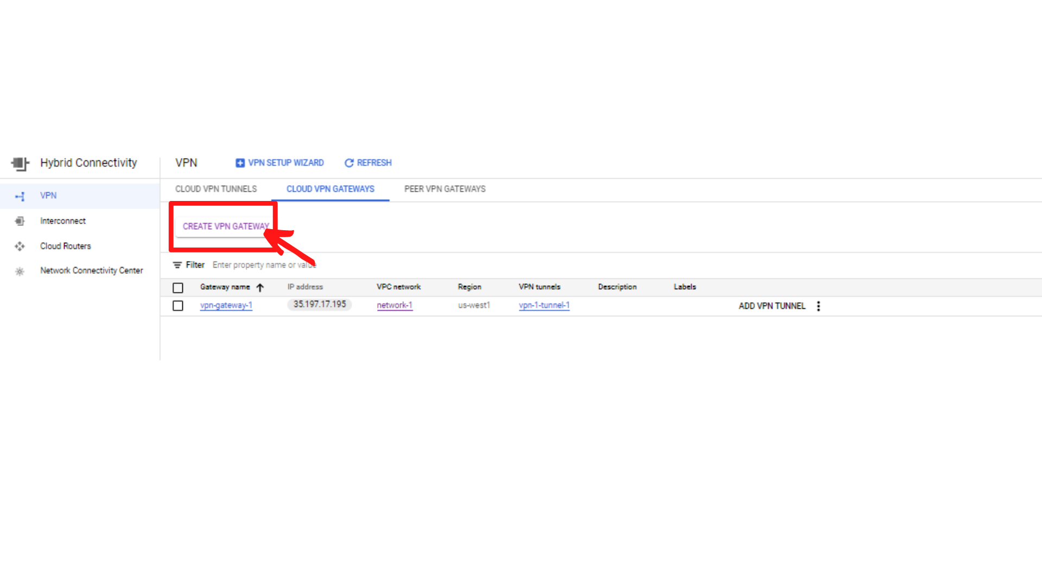

1. Your screen should look similar to this. ***Click on “To create a Classic VPN click here”***

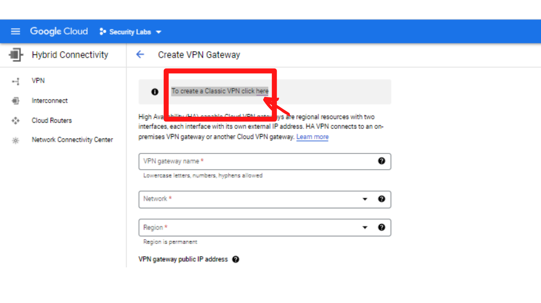

1. Now you will see a similar screen to this with ***“Google Compute Engine VPN gateway”*** Form, Enter the following information.

**Name: *“vpn-gateway-2”***

**Network:** Select “***network-2”***

**Region:** select ***“us-west2 (Los Angeles)”***

**IP address:** Select ***“ips-gateway-address-2”***

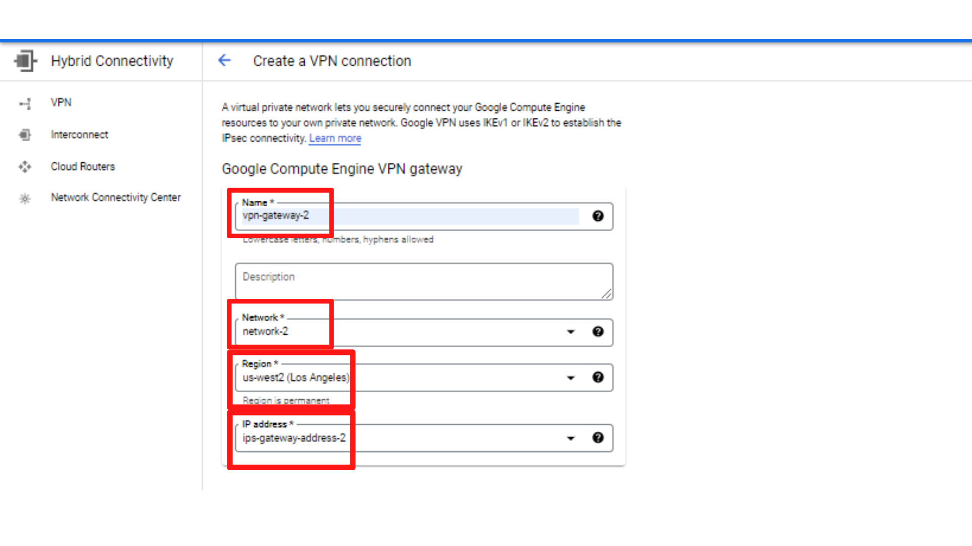

1. Now scroll down, you will see “Tunnels” Form.

Enter the following information.

**Name:** ***vpn-2-tunnel-2***

**Remote peer IP address:** ***“ips-gateway-address-1”*** you need add second static reserved IP address i.e ips-gateway-address-1

**IKE pre-shared Key:*“Paste the shared key from the text file i.e first VPN shared key”***

**Routing options:** Select ***“Route-based”***

Remote IP Network Ranges: Enter the instance-1 network-1 -subnet-1 IP range i.e **10.0.1.0/24**

Then **“click → Done”**

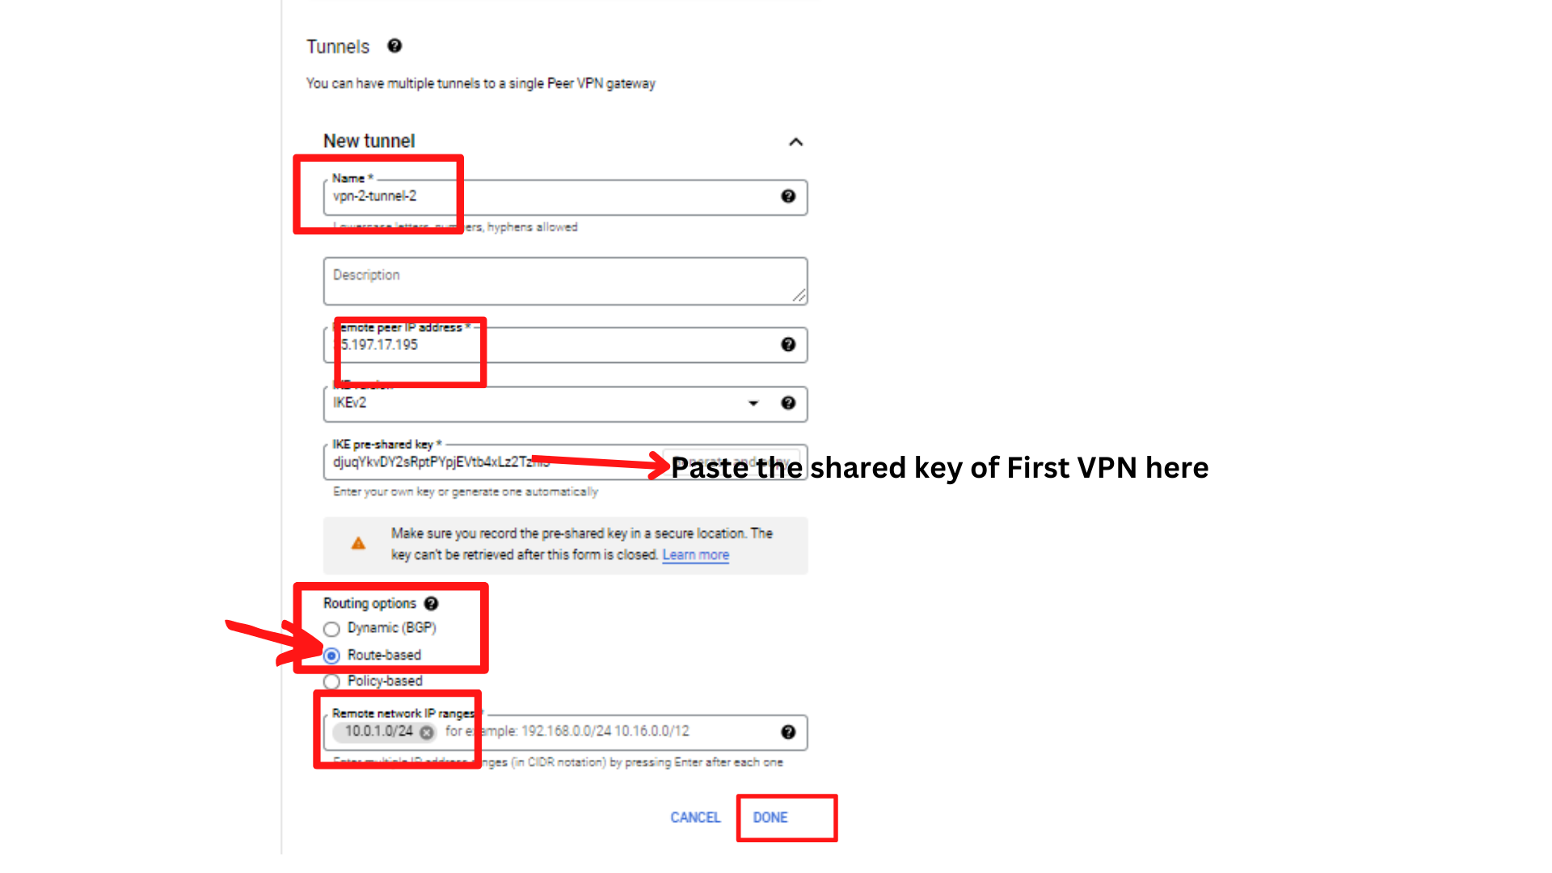

1. Then ***“click → Create”***
2. Your screen should look similar to this with a new VPN and tunnel for network-2.

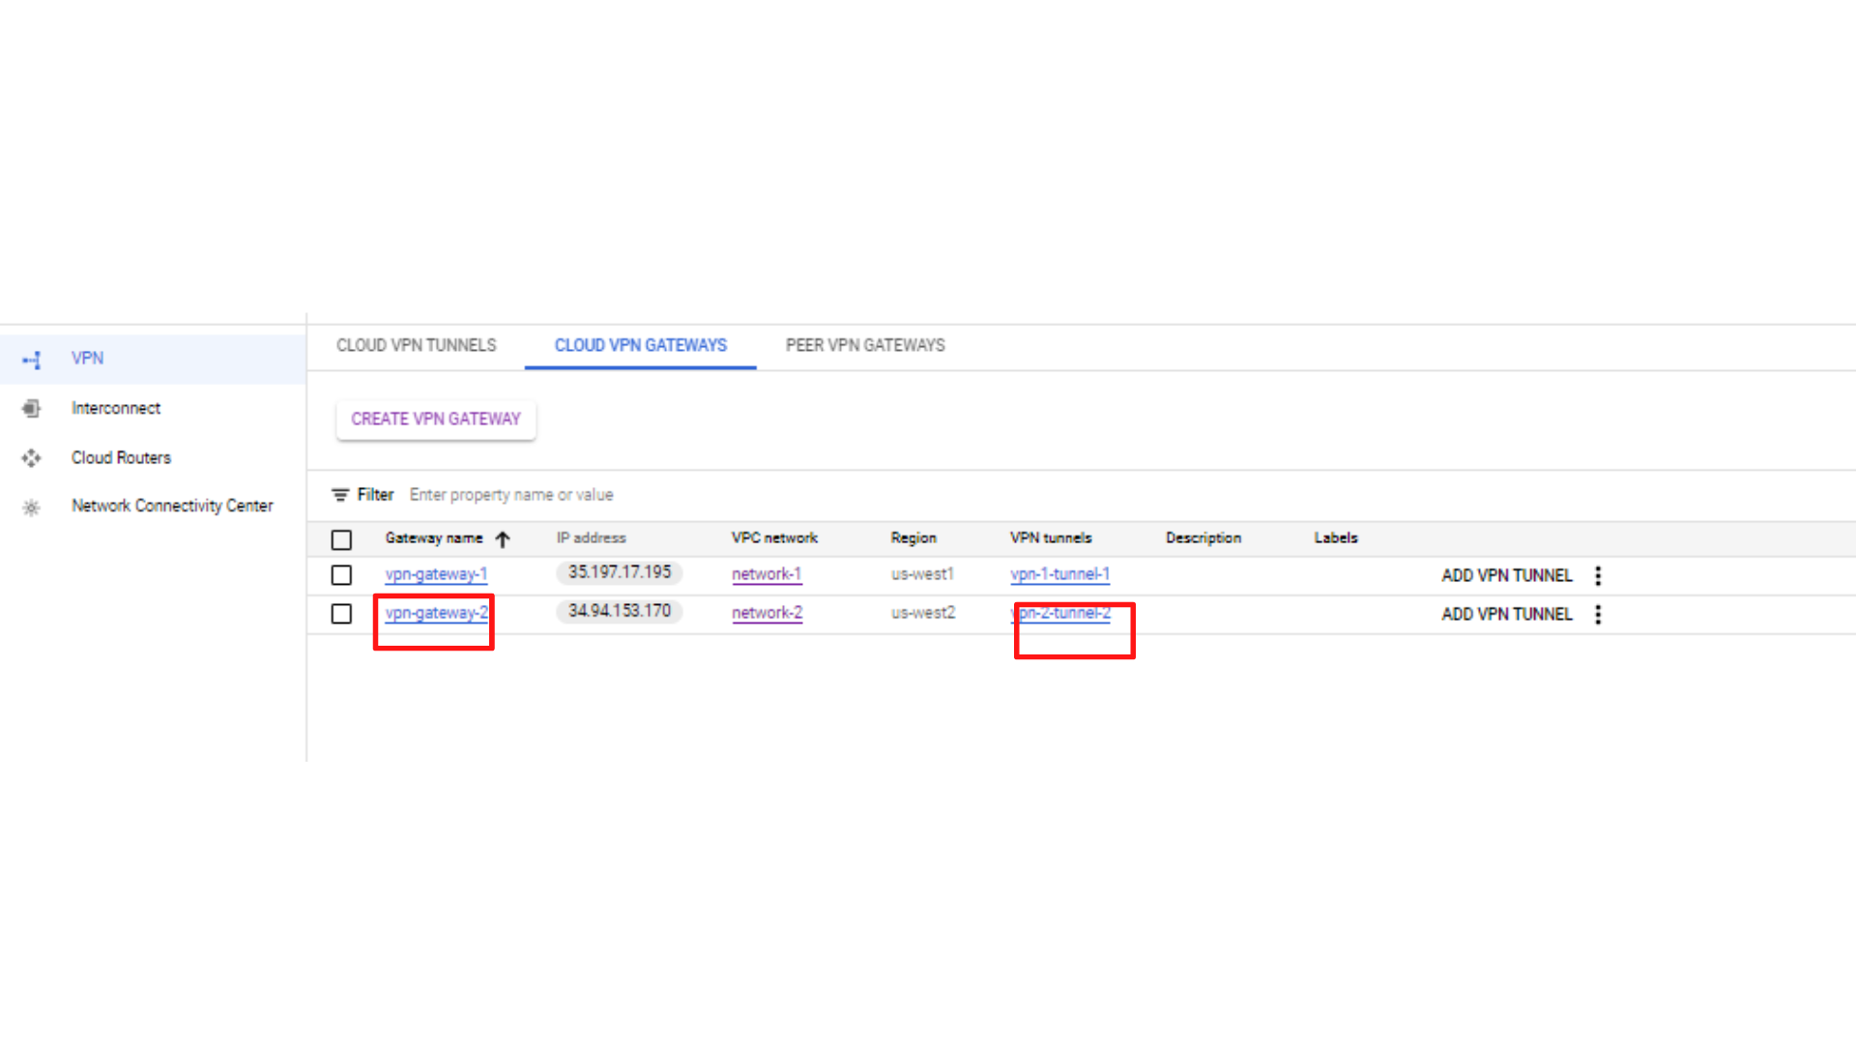

1. If done correctly, both VPN gateways should establish a connection after a few minutes. If you have a green checkmark that says “Established” under the *“****Cloud VPN tunnels*”** column, then you are successfully connected.

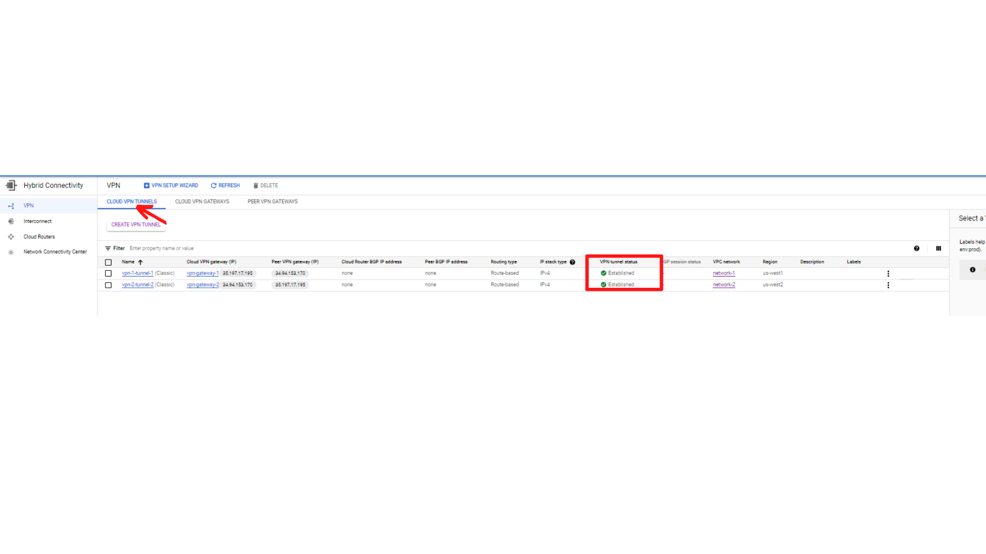

**Step4:** Test for Internal Network Connectivity.

1. Click on ***“Navigation menu”*** on top left, then click on ***“Compute Engine → VM Instances”***

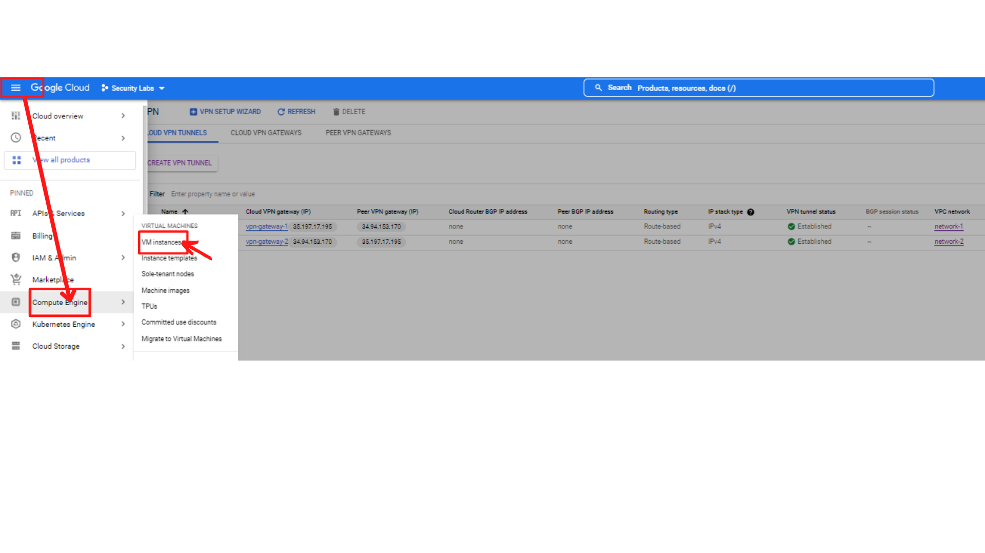

1. Your screen should look similar to this with all instances. ***“Click on instance-1 → SSH”***, this will open a new browser window with SSH-in-browser.

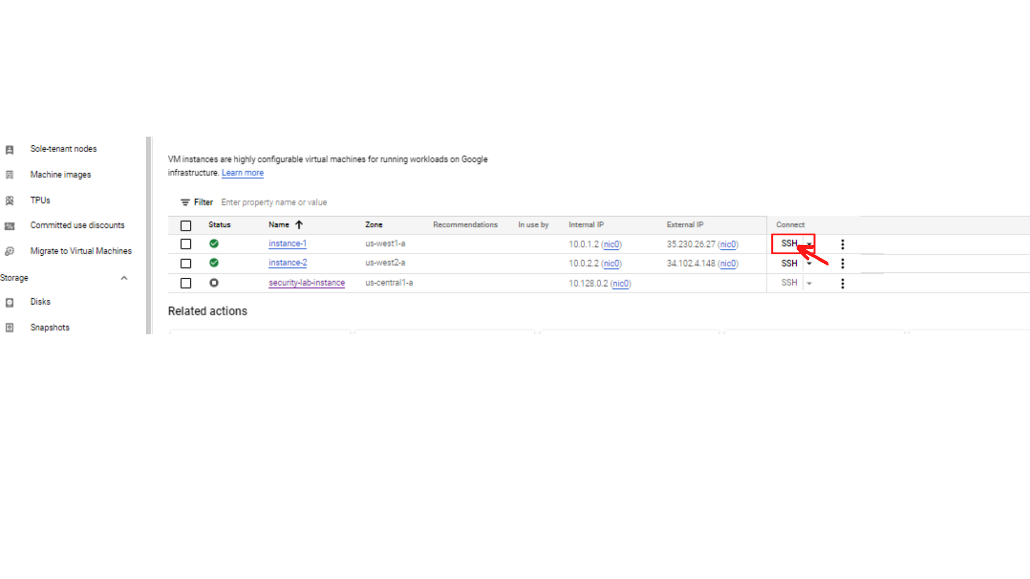

1. Your screen should look similar to this.

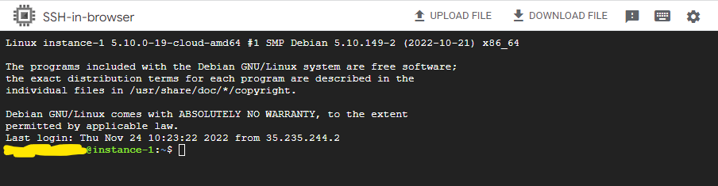

1. Now Attempt to ping instance-2 over its internal IP address by typing ping <internal ip>

ping 10.0.2.2

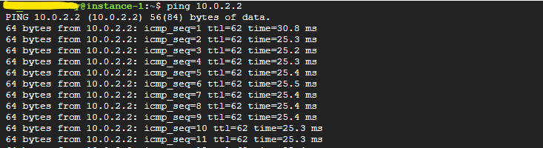

1. **The above screenshot shows you are receiving a response, that means you have successfully established a private network connection between two separate VPC networks.**
2. Now ping instance-1 from instance-2. ***“Click on instance-2 → SSH”***, this will open a new browser window with SSH-in-browser.

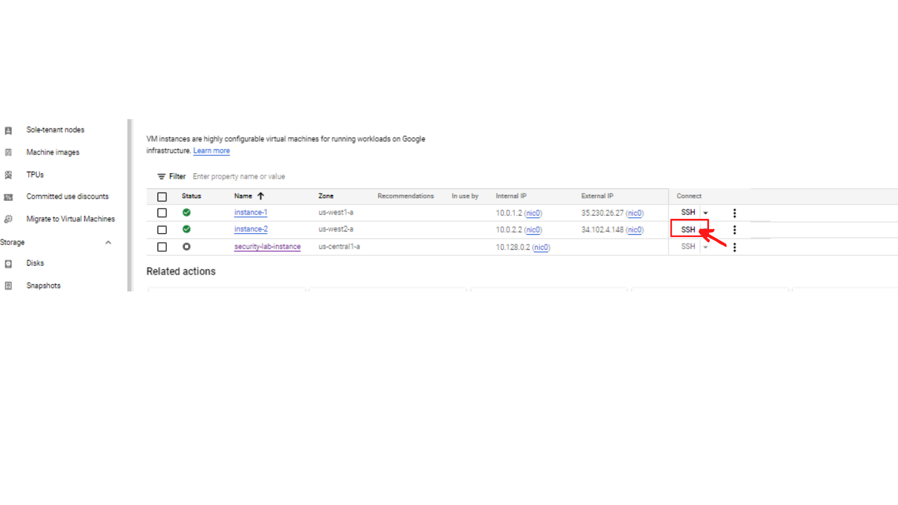

1. Now Attempt to ping instance-1 over its internal IP address by typing ping <internal ip>

ping 10.0.1.2

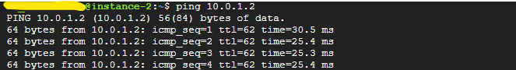

1. **The above screenshot shows you are receiving a response from instance-1.**

**That’s it, you successfully established a private network connection between two separate VPC networks.**

**Architecture Diagram**

